Understand your personal style and the styles of those around you

When I think of myself in relation to other people I am…

Column A Column B
more flamboyant _____ or more restrained _____
more spontaneous _____ or more deliberate _____
more responsive _____ or more detached _____
more impulsive _____ or more methodical _____
more sociable _____ or more aloof _____
more sentimental _____ or more analytical _____
more people-oriented _____ or more task-oriented _____
more outgoing _____ or more reserved _____
more dramatic _____ or more self-controlled _____
more friendly _____ or more unfriendly _____

(do not total Column A) Your total in Column B _____ His/her total _____

Understand your personal style and the styles of those around you

When I think of myself in relation to other people I am...

Column C Column D
more animated _____ or more passive _____
more “take charge” _____ or more “go along” _____
more assertive _____ or more hesitant _____
more demanding _____ or more accepting _____
more demonstrative _____ or more thoughtful _____
more confronting _____ or more supportive _____
more talkative _____ or more quiet _____
more bold _____ or more timid _____
more intense _____ or more subdued _____
more direct _____ or more indirect _____

Your total in Column C _____ (do not total Column D)
His/her total _____

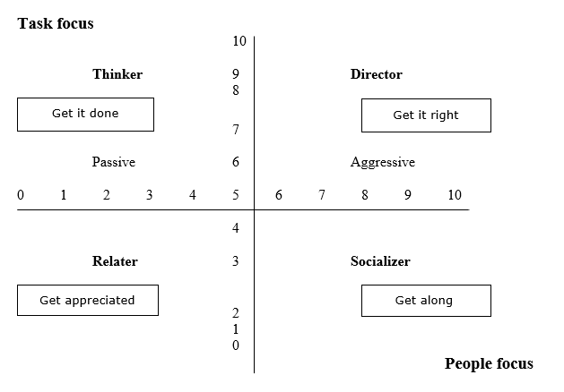
Strengths and weaknesses of behavior styles

Thinkers
“Get it right” people

Behavior characteristics
Focus on tasks
Intend to “get it right”
Pay attention to details, think systematically
Need to be correct
Communicate indirectly and detailed

Strengths:

_________________ _________________ _________________ _________________

Personal stressors:

_________________ _________________ _________________ _________________

When under pressure, thinkers tend to:
Become silent
Flee or withdraw
Exhibit negative behavior

Ineffective behaviors Effective behaviors
for dealing with thinkers: for dealing with thinkers:

Complainers complain because something isn’t “right” and they don’t know how
to fix it.
- Move them into the “problem-solving” mode step-by-step
- Provide information that answers “who, what, where, why and how”

Strengths and weaknesses of behavior styles

Directors
“Get it done” people

Behavior characteristics
Focus on tasks
Intend to “get it done”
Focused, direct, blunt
Need to be in control
Communicate directly and to the point

Strengths:

_________________ _________________ _________________ _________________

Personal stressors:

_________________ _________________ _________________ _________________

When under pressure, directors tend to:
Raise their voice
Bully and take pot shots at others
Behave arrogantly

Ineffective behaviors Effective behaviors
for dealing with directors: for dealing with directors:

Strengths and weaknesses of behavior styles
How to give an assertive person an alternative to direct conflict:

Give them an out ... and the last word!

Socializers
“Get appreciated” people

Behavior characteristics
Focus on people
Intend to “get appreciated”
Display creativity, warmth, charisma and energy
Need to be recognized and applauded
Communicate directly and elaborately

Strengths:

_________________ _________________ _________________ _________________

Personal stressors:

_________________ _________________ _________________ _________________

When under pressure, socializers tend to:
Talk more loudly and quickly
Throw tantrums
Exaggerate

Ineffective behaviors Effective behaviors
for dealing with socializers: for dealing with socializers:

Strengths and weaknesses of behavior styles
What to do when someone criticizes you unfairly:

Confront by asking questions regarding their intent.

Relaters
“Get along” people

Behavior characteristics
Focus on people
Intend to “get along”
Behave in an agreeable, personable, friendly, caring and helpful manner
Need to be liked
Communicate indirectly and considerately

Strengths:

_________________ _________________ _________________ _________________

Personal stressors:

_________________ _________________ _________________ _________________

When under pressure, relaters tend to:
Submit
Accommodate
Exhibit passive-aggressive behaviors

Ineffective behaviors Effective behaviors
for dealing with relaters: for dealing with relaters:

What to do when somebody makes a promise you suspect he or she won’t keep:

Confirm and reconfirm mutually acceptable decisions.

